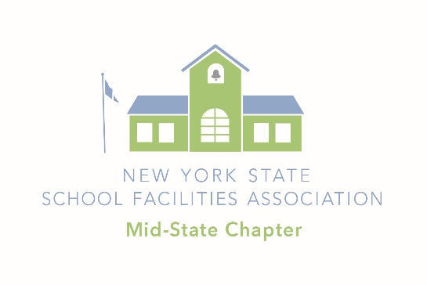
2023 NYSSFA Mid-State Chapter Scholarship Application

Receipt Deadline is March 24th 2023

The Mid-State Chapter Scholarship is awarded based upon both merit and need. Scholarships are valued at $2000.00 each. Scholarship applications are evaluated on achievements/accomplishments, involvement, letter of professional intent, recommendation letter, etc. Please review the entire application to make sure you understand all of the requirements.

Students have sole responsibility for ensuring accuracy and compliance. Any variance from requirements will be cause for disqualification. Decisions of the scholarship judges are final. No telephone calls please.

Eligibility requirements for all applicants:
- Must be a graduating senior intending to pursue a degree or vocational program in a field related to Facility Management. Building trade schools; most engineering and architecture disciplines do qualify. If unsure please contact us by email to clarify.
- No minimum GPA is required, but this metric is considered in our evaluation of candidates.
Please provide all information requested. Make sure to indicate your address, phone number and email address neatly so we can contact you any time with questions and notices.

Name: Date: ___

Current Address:

_________

_________

_________

Home Phone: _____________________

Cell Phone: _____________________

E-Mail: _____________________

College/University you are planning to attend or course of study:

________________________________________________________________________

What is your current high school GPA? _____________

Required Scholarship Application Content

Please answer each of the following “Scholarship Application Required Elements” in the order as follows. Please make sure you clearly identify each element. Application judging will follow this order.

Academics and Leadership (Resume)
(50 possible total points)

- Primary Course of Study GPA – 10pts.
Include / attach a copy of your high school transcript.

- Academic Achievements/Accomplishments – 10pts.
Please list any academic awards or honors you have received as well as any notable accomplishments. They don’t have to be Facilities Management related.

- Academic (and/or) Civic Leadership Skills – 10pts.
List those instances when you have excelled in a leadership role; be specific.

- Academic (and/or) Civic Team Skills – 10pts. (include employment history)
List those activities you have been involved in that required team interaction and communication. What was your role and how did you handle it?

5. Letter of Recommendation – 10pts.
Please attach a letter of recommendation from any one of the following: teacher, administrator, employer, or volunteer coordinator.

Facility Management Elements
(20 possible total points)

6. Definition of Facility Management – 10pts.
Please define “facility management” in your own words.

7. Explain Your Future Facility Management or Related Aspirations / Letter of
Professional Intent – 10pts.
Please attach a letter of professional intent describing your short and long-term career goals in facility management or related field. Please do not describe what you have done, but what you plan to do in your career. (A short paragraph or two is sufficient, but feel free to provide more detail if you wish). Please tell us about any challenges or obstacles you expect may affect the achievement of your goals.

Scholarship Application Quality
(30 possible total points)

8. Application Appearance and Organization – 10pts.
Professional appearance and presentation. Did the submitted application follow the guideline?

9. Unique and Exemplary Impression – 20pts.
Creative and lasting impression. Did the application leave a positive lasting impression?

Judging Guidelines

Note: Your completed application along with all of the supporting documents must be submitted together. Please format your application in the order items are listed above. Items 1-5 are recommended to be in a resume format (Clear and Concise). We will not accept additional or edited documents once the initial application and supporting documents have been received.

Judging is done by the scholarship committee and is a time-consuming task; therefore, specific requirements have been established for all submittals to ensure the judging process is as objective as possible. Please fill out the application form thoroughly. Once the deadline has been reached, all eligible applications and supporting documentation will be assembled in an electronic file for each judge. Any submission not meeting these criteria will be disqualified. Please follow the specific guidelines below:

- Type or computer-generate the form and supporting documents. Font should be 10-12 point standard, easy-to-read fonts.

- All PDF applications should be sent via email to Vinny Smith at vsmith@jecsd.org. If submitting on-line be sure to attach all supporting documents. If you are able, please scan all documents and send as a single PDF for submission.

3. If you prefer to mail your application, please be sure the postmark is prior to deadline.

Send to: Mr. Vinny Smith
Director of Facilities
Jordan-Elbridge CSD
PO Box 902
Jordan, NY 13080

Scholarship Timeline of Activities

- Scholarship applications and supporting documents accepted beginning in January of 2023 and must be postmarked no later than March 24, 2023 for consideration.

- Scholarship judging to be completed late April 2023.

